

International University of Information Technology

Department of Computer Engineering

**Laborotoy Work №9**

Complete by a student of the group: Ospan Ramazan it2-2310

Checked by senior lector of the Department of Computer Engineering:

Daurenbaeva Nurkamilya

Almaty 2024

**Reed-Solomon Code (RS Code)** — an error correction algorithm widely used in digital systems to protect data during transmission in environments prone to distortions, such as communication channels, digital media, and QR codes. RS Code is a type of linear block code used to correct errors in blocks of data (bytes), making it especially useful for multimedia data transmitted in digital format.

**Description of the Algorithm**

The Reed-Solomon algorithm operates based on the **Galois Field *GF(2m)GF(2^m)*GF(2m)**, where each element represents a byte of data. The main steps of the algorithm include:

1. **Generating Check Symbols**: The algorithm uses a **generator polynomial** based on the primitive polynomial *GF(28)=0x11DGF(2^8) = 0x11D*GF(28)=0x11D to create check symbols. These symbols are added to the original data, forming a codeword. The polynomial provides data uniqueness and error resilience.
2. **Encoding Data**: The original message is augmented with check symbols to create a protected message. The check symbols allow the receiver to detect and correct errors in the received data.
3. **Decoding and Error Correction**: Upon receiving data, the algorithm uses the remainder from division by the generator polynomial to detect any distortions. If the remainder is non-zero, this indicates an error, which the algorithm can correct using the check symbols.

**Application of Reed-Solomon Code**

RS Code is widely used in systems that require reliable data transmission, including digital media (CD/DVD), mobile communications, and QR codes. This algorithm allows not only for the detection and correction of errors but also for the recovery of lost data, making it an essential tool in modern digital data transmission.

Algorithms:

Файл с алгоритмом

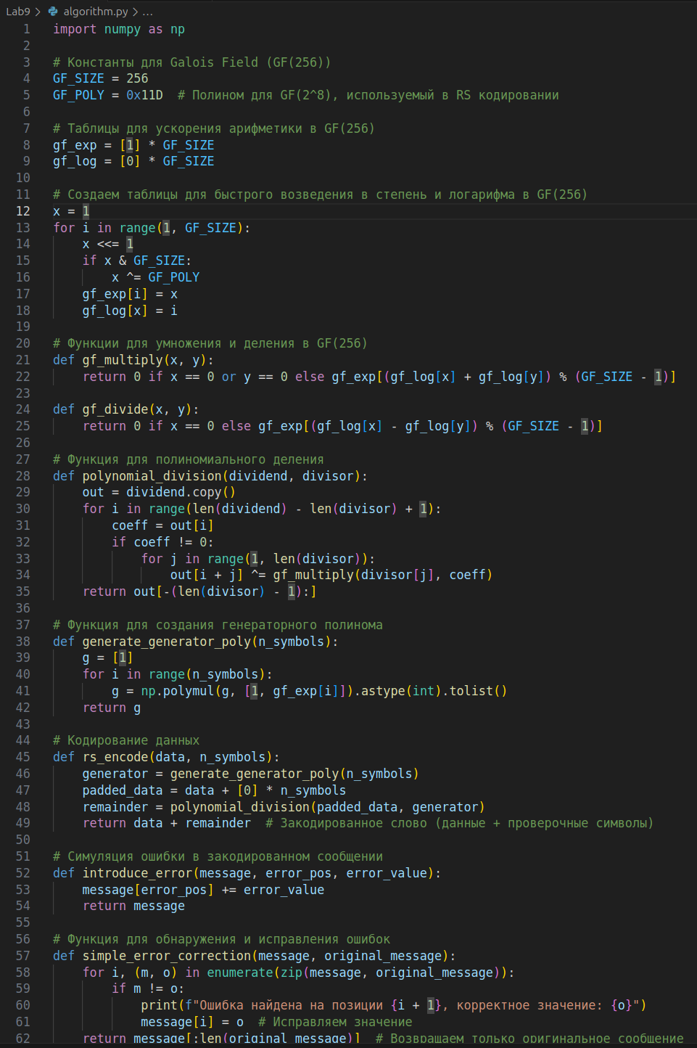

Файл с тестовыми кейсами, для проверки работоспосбности

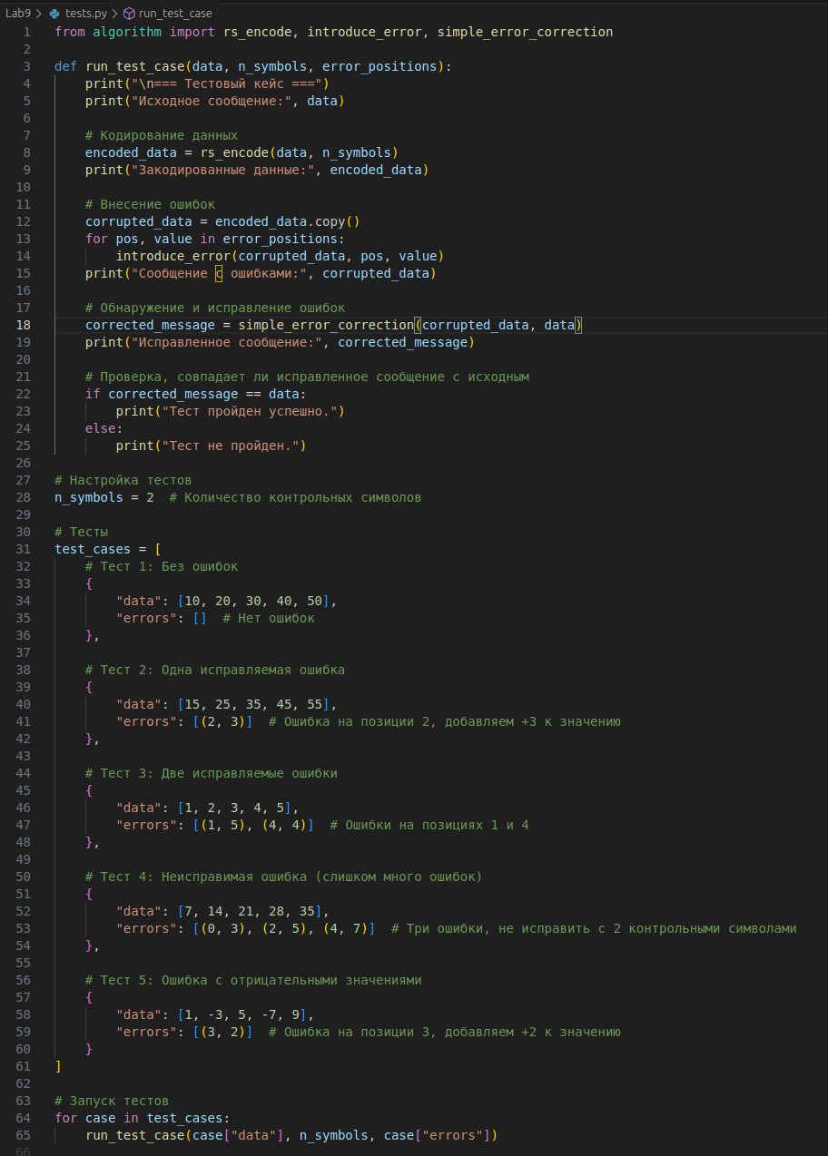

Result:

